**[37] Design NFA Which Accepts Strings That Starts And Ends With Different Inputs**

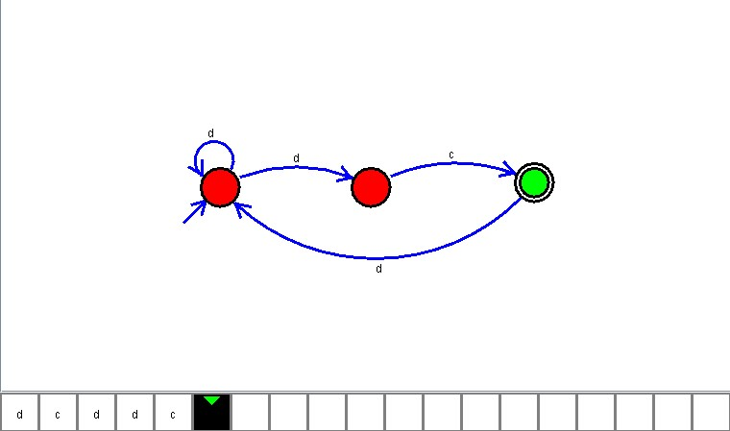

**Result**

The NFA is designed to compute the given strings as input using Simulator